     

Scoil Mhuire Gleann A’Chaisil

Bun na hAbhna, Béal an Átha, Co. Mhaigheo

(097) 82283
www.glencastlens.ie
email:gleannachaisil@gmail.com
Charity Number 20129552

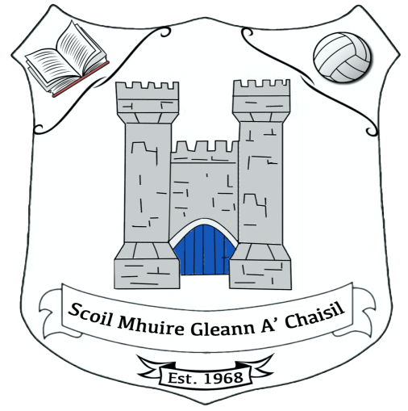

Rolla Number 13222P

Annual Admissions Notice for the 2023/2024 School Year

Admission Policy and Application Form:
A copy of the school’s Admission Policy is available as follows:
To download at: www.glencastlens..ie
By phoning: 097 82283
By emailing: gleannachaisil@gmail.com @gmail.com
By writing to: Glencastle N.S., Bunnahowen P.O., Ballina, Co. Mayo. F26 NP79
Application and Decision Dates for admission to Glencastle National School for school year 2023/2024:
The following are the dates applicable for admission to Junior Infants

The school will commence accepting applications for admission in: | October 2022
The school shall cease accepting applications for admission in: | May 2023
The date by which applicants will be notified of the decision on their application is | June 2023
The period within which applicants must confirm acceptance of an offer of admission is | 1 month

The following are the dates applicable for admission to the school’s Autism Class which caters for children with autism:
The school will commence accepting applications for admission to the Autism class in | October 2022
The school shall cease accepting applications for admission to the Autism class in | March 2023
The date by which applicants will be notified of the decision on their application for admission to the Autism class is | June 2023
The period within which applicants must confirm acceptance of an offer of admission is | 1 month

The following are the dates applicable for admission to the school’s Multiple Class which caters for children with two or more low incident disabilities
The school will commence accepting applications for admission to the Multiple class in | October 2022
The school shall cease accepting applications for admission to the Multiple class in | March 2023
The date by which applicants will be notified of the decision on their application for admission to the Multiple class is | June 2023
The period within which applicants must confirm acceptance of an offer of admission is | 1 month

The following are the dates applicable for admission to the school’s Early Intervention Autism Class which caters for children with autism between the ages of 3 years and 5 years and 11months.
The school will commence accepting applications for admission to the Early Intervention Autism class in | October 2022
The school shall cease accepting applications for admission to the Autism class in | May 2023
The date by which applicants will be notified of the decision on their application for admission to the Autism class is | June 2023
The period within which applicants must confirm acceptance of an offer of admission is | 1 month

*Note: Failure to accept an offer within the prescribed period above may result in the offer being withdrawn.
The school will consider and issue decisions on late applications in accordance with the school’s admission policy.

Number of places being made available in Glencastle National School:
The number of places being made available in junior infants is: 28
The number of places being made available in the Autism class catering for children with autism is: 2 (Cubs) 0 (Busy Bees) 0 (Explorers) 0 (Detectives)
The number of places being made available in Junior Infants is | 20
The number of places being made available in our ASD class is | 1
The number of places being made available in our Multiple Class is: | 1
The number of places being made available in our Early Intervention Autism Class is | 5

